Table 1 Type of restaurant liked most, by social class (percentages)

 | Professional  executive | Intermediate  class | Working  class | Never  worked | all | sig
Café or teashop | 2 | 3 | 6 | 7 | 4 | **
Pizza house | 2 | 1 | 5 | 11 | 3 | ***
Fast food | 1 | 3 | 4 | 12 | 3 | **
Fish and Chip | 1 | 2 | 4 | 2 | 2 | *
Pub/Wine bar/hotel | 16 | 26 | 25 | 7 | 22 | ***
Indian | 13 | 12 | 12 | 9 | 13
Chinese/Thai | 19 | 21 | 18 | 16 | 18
Italian | 23 | 14 | 9 | 16 | 14 | ***
French | 14 | 9 | 3 | 5 | 7 | ***
Traditional steak house | 4 | 8 | 10 | 2 | 8 | **
Vegetarian | 3 | 2 | 3 | - | 3
None/Don’t eat out | 1 | 1 | 3 | 5 | 2 | *
N= | 361 | 449 | 710 | 43 | 1563

Pearson Chi-Square *** <.001, ** <.01, * <.05
Notes: For social class categorisation see LeRoux et al (2008). Class is allocated on the basis of respondent’s current or most recent occupation.
The question asked was:
Table 2 Type of restaurant least liked, by social class (percentages, by column)

 | Professional  executive | Intermediate  class | Working  class | Never  worked | all
Café or teashop | 3 | 3 | 2 | - | 2
Pizza house | 2 | 3 | 5 | 2 | 4 | *
Fast food | 52 | 44 | 29 | 19 | 38 | ***
Fish and Chip | 6 | 7 | 4 | 7 | 5
Pub/Wine bar/hotel | 0 | 0 | 1 | 7 | 1 | ***
Indian | 6 | 10 | 12 | 7 | 10 | *
Chinese/Thai | 3 | 6 | 8 | 5 | 6 | *
Italian | 0 | 2 | 2 | - | 1
French | 3 | 3 | 7 | 19 | 5 | ***
Traditional steak house | 3 | 1 | 2 | 2 | 2
Vegetarian | 19 | 21 | 26 | 28 | 23 | ***
None/Don’t eat out | 3 | 1 | 2 | 5 | 2
N= | 361 | 449 | 710 | 43 | 1563

Pearson Chi-Square *** <.001, ** <.01, * <.05
Figure1: Axis 1 and 2, with variables contributing to axis 1 indicated

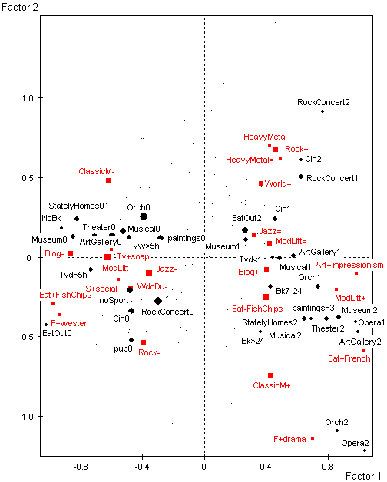

Figure 2
MCA: Social position of survey respondents in cultural space and identification of qualitative interviewees

? Includes only respondents from the main sample (N=1564). The individuals interviewed qualitatively who do not belong to the main sample (ethnic minority boost and focus groups samples) are not identified on the MCA.

