Tablas y pies de tablas

ASSOCIATION/SUBASSOCIATION | Nº REL. | SYNTAXONOMY | ECOLOGICAL CATEGORIES
Spartinetum densiflorae Rivas-Martínez, Costa, Castroviejo & E. Valdés 1980 | 4 | SPARTINETEA MARITIMAE  Spartinetalia maritimae  Spartinion maritimae | III Coastal and continental halophilous and sand dune vegetation  IIIb Coastal and continental halophilous vegetation
Halimiono portulacoidis- Sarcocornietum alpinii Rivas-Martínez & Costa 1984 | 11 | SARCOCORNIETEA FRUTICOSAE Sarcocornietalia fruticosae Arthrocnemion machrostachyi
Erico australis–Cistetum populifolii Rivas Goday 1964 | 5 | CALLUNO VULGARIS-ULICETEA MINORIS  Ulicetalia minoris  Ericion umbellatae | VIII Heathland, dwarf scrub and scrub vegetation  VIIIa Heathland, and dwarf scrub vegetation
Erico scopariae–Ulicetum australis Rivas-Martínez, Costa, Castroviejo & E. Valdés 1980 | 1
Halimio ocymoidis–Ericetum umbellatae Rivas Goday 1964 | 1
Genisto hirsutae–Cistetum ladaniferi cistetosum ladaniferi Rivas Goday 1956 | 46 | CISTO-LAVANDULETEA STOECHADIS  Lavanduletalia stoechadis  Ulici argentei – Cistion ladaniferi
Genisto hirsutae–Cistetum ladaniferi ericetosum australis Rivas Goday 1956 | 26
Ulici eriocladi–Cistetum ladaniferi Rivas-Martínez 1979 | 15
Scillo maritimae–Lavanduletum pedunculatae Ladero 1970 | 3
Halimio halimifolii–Stauracanthetum genistoidis Rivas-Martínez, Costa, Castroviejo & E. Valdés 1980 | 28 | Stauracantho genistoidis–Halimietalia calycini  Coremation albi

Table 1. Syntaxonomical and ecological framework of the associations and sub-associations identified, and number of relevés for each one,

Number of relevés | 4 | 11 | 28 | 1 | 3 | 46 | 15 | 26 | 5 | 1
Number of column | 1 | 2 | 3 | 4 | 5 | 6 | 7 | 8 | 9 | 10
Spartina densiflora Brongn. | 4, 5 | III, +
Halimione portulacoides (L.) Aellen | 4, 1-2 | V, +-1
Limoniastrum monopetalum (L.) Boiss. | 1, 2 | II, +
Sarcocornia perennis subsp. alpini (Lag.) Castrov. | 3, 2 | V, 4-5
Artrocnemum macrostachium (Moric.) Moris |  | I, 1-2
Stauracanthus genistodes (Brot.) Samp. |  |  | III, 2
Helichrysum picardii Boiss. & Reut. |  |  | II, +-2
Halimium halimifolium subsp. halimifolium (L.) Willk. |  |  | V, 3-4 | 1, 3 |  | +, + |  | r, +
Halimium calycinum (L.) K. Koch |  |  | III, 1-2 |  |  | r, 1-2
Cytisus grandiflorus (Brot.) DC. |  |  | II, 1-2 |  |  | r, +
Armeria velutina Welw. ex Boiss & Reut. |  |  | I, + | 1, +
Erica scoparia L. |  |  | r, 1 | 1, 2 |  |  |  | r, +
Ulex australis subsp. australis Clemente |  |  | III, 2 | 1, 2 |  | r, +-1 |  | r, 1
Lavandula pedunculata (Mill.) Cav. |  |  | II, 2 |  | 3, 4 |  | +, 2
Urginea marítima (L.) Baker |  |  |  |  | 2, + | r, + | +, + | r, r
Genista hirsuta Vahl |  |  | +, r-1 |  | 2, 1-2 | III, 2 | II, 1 | II, 2 | 3, +
Cistus ladanifer L. |  |  | +, r-+ |  | 2, + | V, 4-5 | V, 4-5 | V, 5 | 5, 2 | 1, 1
Cistus monspeliensis L. |  |  | I, + |  | 1, 2 | III, 4 | II, 2 | I, 1
Phlomis purpurea L. |  |  |  |  |  | +, 2
Ulex eriocladus C. Vicioso |  |  |  |  |  |  | V, 2
Erica australis L. |  |  |  |  |  | r, r-+ | I, 1 | V, 3-4 | 5, 4 | 1, 1
Erica umbellate Loefl. ex L. |  |  | +, +-1 |  |  | r, +-1 | +, r | IV, 2 | 5, 2 | 1, 4
Halimium ocymoides (Lam.) Willk. |  |  |  |  |  | r, + |  | II, +-1 | 2, 1 | 1, 3
Genista triacanthos Brot. |  |  | +, 1 |  |  | r, r-1 |  | I, +-1 | 1, +
Cistus populifolius L. |  |  |  |  |  | r, 3 |  | II, + | 5, 1-3
Pterospartum tridentatum subsp. lasianthum (Spach.) Talavera & P.E. Gibbs |  |  |  |  |  |  |  | IV,1-2 | 3, 2 | 1, 2
Phillyrea angustifolia L. |  |  | r, r |  |  |  | +, r | I, r-1 | 2, 1
Chamaerops humilis L. |  |  | +, r-2 |  |  | I,+-1-2
Cistus salviifolius L. |  |  | III, 1-2 |  | 1, 1 | +, + | I, 1-3 | II, + | 1, +
Asparagus aphyllus L. |  |  | I, r |  |  | I, +
Calluna vulgaris (L.) Hull |  |  | II, r-1 | 1, 2 |  |  |  | I,+-1-2
Rosmarinus officinalis L. |  |  | II, 1-2 | 1, + |  | I, 2 |  | I, 2 | 1, 1
Helichrysum stoechas (L.) Moench |  |  | I, r-1 | 1, + |  | I, + |  | r, + | 1, +
Lavandula stoechas subsp. stoechas L. |  |  | I, 1 |  |  | II, 1 | III, 1 | III, 1
Thymus mastichina (L.) L. |  |  | II, 1 |  |  | +, +
Cistus crispus L. |  |  | +, r-2 |  | 1, 2 | r, 1 | I,+-1-2
Carlina corymbosa subsp. hispanica (Lam.) O. Bolós & Vigo |  |  | +, + |  | 1, 1 | I, + | I, +-1 | +, +
Olea europea L. |  |  |  |  |  | +, r-+ | +, 1
Quercus rotundifolia Lam. |  |  |  |  |  | I, r-+ | II, 2 | +, + | 1, +
Arbutus unedo L. |  |  |  |  |  |  |  | II, + | 2, +
Phagnalon saxatile (L.) Cass. |  |  |  |  |  | I, + | +, 2
Pistacia lentiscus L. |  |  |  |  |  | +, r-1 | +, + |  | 1, +
Lavandula stoechas subsp. luisieri (Rozeira) Rozeira |  |  |  |  |  | I, 1 | II, 1-2 | II, + | 2, + | 1, +
Lavandula viridis L’Hér. |  |  | +, 2 | 1, 2 |  | r, r-+ |  | +, 1 | 2, 1-2
Asparacus acutifolius L. |  |  |  |  |  | r, + | +, +
Retama sphaerocarpa (L.) Boiss. |  |  |  |  |  | +, 2 | +, + | r, +
Quercus coccifera L. |  |  |  |  |  | r, +-2 |  | +, r-1
Myrtus communis L. |  |  | +, r-1 |  |  | r, +-1 |  | II, 1
Quercus suber L. |  |  |  |  |  |  |  | +, r-1 | 2, r-+
Cistus libanotis L. |  |  | +, 1 |  |  | r, +
Ulex argenteus subsp. subsericeus (Cout.)Rothm. |  |  | +, 2 |  |  | I, 2 |  | r, 3
Elaeoselinum foetidum (L.) Boiss. |  |  |  |  |  | +, +
Dactylis glomerata L. |  |  |  |  | 2, +-1 | r, +
Thapsia villosa L. |  |  | II, + |  |  | r, + | +, +

Table 2. Table of synthesis of the syntaxa identified. 1. Spartinetum densiflorae. 2. Halimiono portulacoidis - Sarcocornietum alpinii. 3. Halimio halimifolii–Stauracanthetum genistoidis. 4. Erico scopariae–Ulicetum australis. 5. Scillo maritimae–Lavanduletum sampaianae. 6. Genisto hirsutae–Cistetum ladaniferi cistetosum ladaniferi. 7. Ulici eriocladi–Cistetum ladaniferi. 8. Genisto hirsutae–Cistetum ladaniferi ericetosum australis. 9. Erico australis–Cistetum populifolii. 10. Halimio ocymoidis–Ericetum umbellatae. The Roman or Arabic numerals situated in the first place indicate the type of presence of the taxon. The Arabic numerals or symbols that follow indicate the value of the most frequent Braun-Blanquet cover-abundance scale of the taxon in the corresponding syntaxon.

Phytosociological classification |  | TWINSPAN classification
 |  | C1 |  | C2 | C3 | C4 | C5 |  | Total
 |  | I | II | III | IV | V | VI | VII | Total
1 | Spartinetum densiflorae | 4 |  |  |  |  |  |  | 4
2 | Halimiono portulacoidi-Sarcocornietum alpinii | 2 | 9 |  |  |  |  |  | 11
3 | Halimio halimifolii–Stauracanthetum genistoidis |  |  | 28 |  |  |  |  | 28
4 | Erico scopariae–Ulicetum australis |  |  | 1 |  |  |  |  | 1
5 | Genisto hirsutae–Cistetum ladaniferi cistetosum ladaniferi |  |  | 2 | 10 | 32 | 1 | 1 | 46
6 | Scillo maritimae–Lavanduletum sampaianae |  |  |  |  | 3 |  |  | 3
7 | Ulici eriocladi–Cistetum ladaniferi |  |  |  |  | 8 | 7 |  | 15
8 | Genisto hirsutae–Cistetum ladaniferi ericetosum australis |  |  |  | 1 | 3 | 1 | 21 | 26
9 | Erico australis–Cistetum populifolii |  |  |  |  |  |  | 5 | 5
10 | Halimio ocymoidis–Ericetum umbellatae |  |  |  |  |  |  | 1 | 1
Total |  | 6 | 9 | 31 | 11 | 46 | 9 | 28 | 140

Tabla 3. Correspondence between syntaxa and clusters of the Twinspan, original classification (I-VII) and classification of synthesis (C1-C5). In bold the best correspondences.

Vegetation types of synthesis | Landscape types of synthesis
Vegetation types of synthesis | a | b | c | d | e | Total
C1 | 15  (1.6) | 0  (4.3) | 0  (1.3) | 0  (3.9) | 0  (4.0) | 15
C2 | 0  (3.3) | 30  (8.9) | 1  (2.7) | 0  (8.0) | 0  (8.2) | 31
C3 | 0  (1.2) | 3  (3.1) | 7  (0.9) | 0  (2.8) | 1  (2.9) | 11
C4 | 0  (4.9) | 7  (13.1) | 4  (3.9) | 26  (11.8) | 9  (12.2) | 46
C5 | 0  (4.0) | 0  (10.6) | 0  (3.2) | 10  (9.5) | 27  (9.8) | 37
Total | 15 | 40 | 12 | 36 | 37 | 140

Table 4. Contingency table comparing the classifications of the relevés according to the syntheses of landscape types and of vegetation types. Landscape types: a , Marshes; b, Dunes and Sands; c, Campiñas; d, Peneplains and Slopes; e, Sierras. Types of vegetation of synthesis: C1-C5; see table 3. In parentheses and in cursive script are indicated the observed and the expected values. Pearson's chi-squared statistic: X² = 313.83 (v = 16, p<0,001).
Vegetation types of synthesis | Landscape types of synthesis
Vegetation types of synthesis | a | b | c | d | e
C1 | 111.61 | 4.29 | 1.29 | 3.86 | 3.96
C2 | 3.32 | 50.47 | 1.03 | 7.97 | 8.19
C3 | 1.18 | 0.01 | 38.91 | 2.83 | 1.25
C4 | 4.93 | 2.87 | 0.00 | 16.98 | 0.82
C5 | 3.96 | 10.57 | 3.17 | 0.02 | 30.33

Table 5. Pearson's chi-squared terms of the contingency table (Table 4) according to Fisher's exact test, comparing the classifications of the relevés according to the syntheses of landscape types and of vegetation types. Landscape types: a , Marshes; b, Dunes and Sands; c, Campiñas; d, Peneplains and Slopes; e, Sierras. Types of vegetation of synthesis: C1-C5; see table 3.

Figuras y pies de figuras (De la fig. 2 se adjunta imagen en color para formato digital y en blanco y negro para papel)

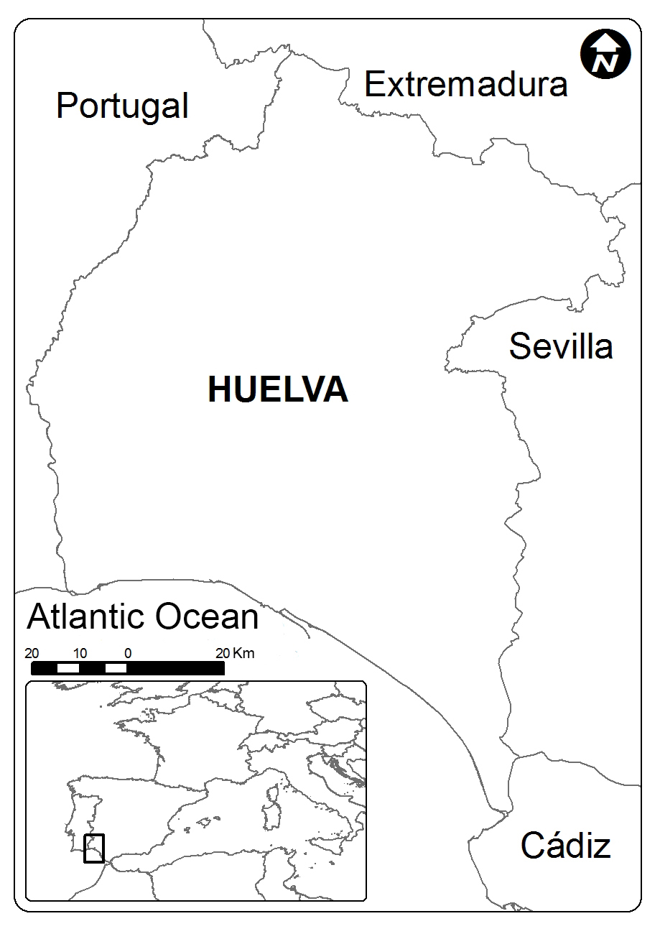

Figure. 1. Map of the study area, Huelva, in Spain.

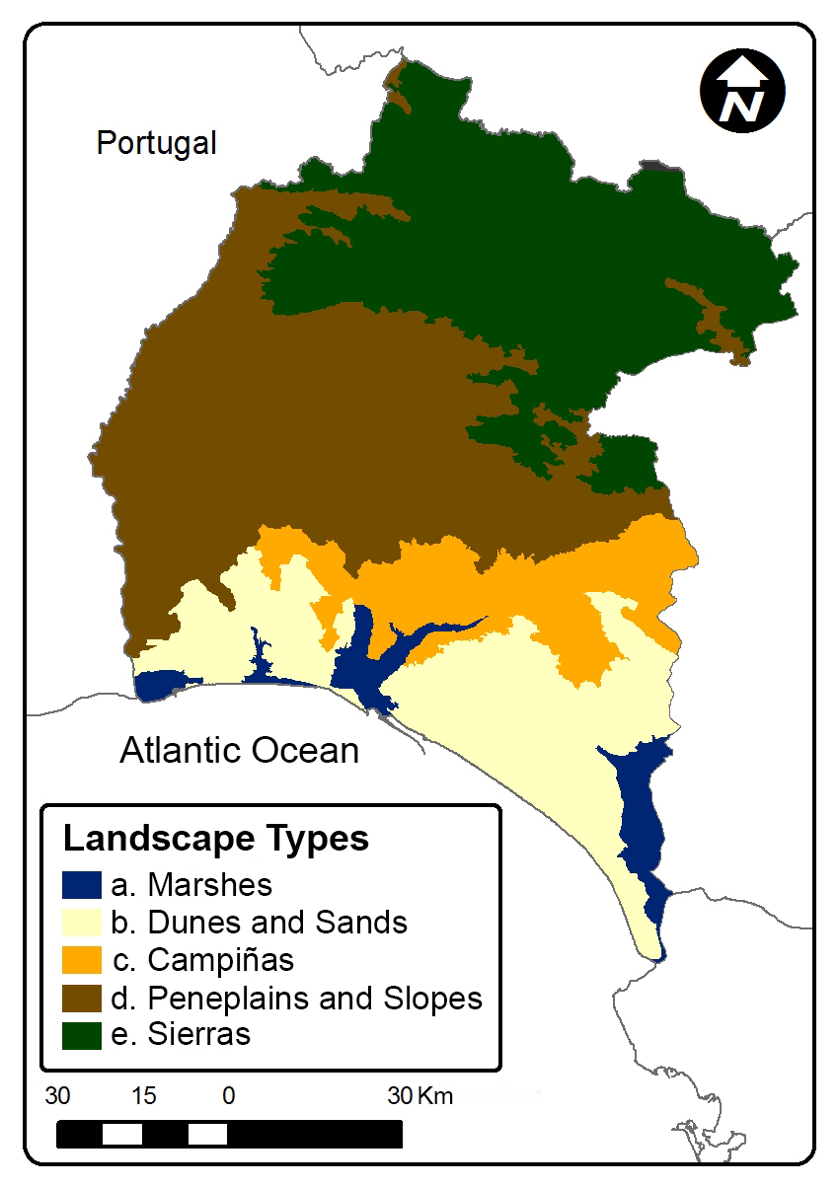

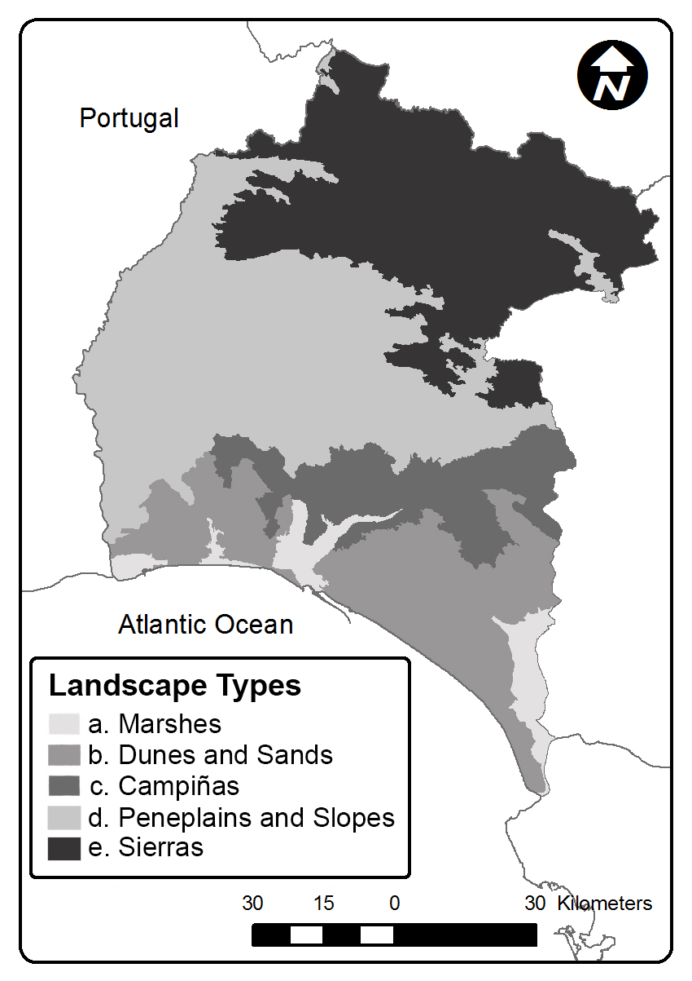

Figure 2. Map of Huelva with the distribution of the landscape types studied.

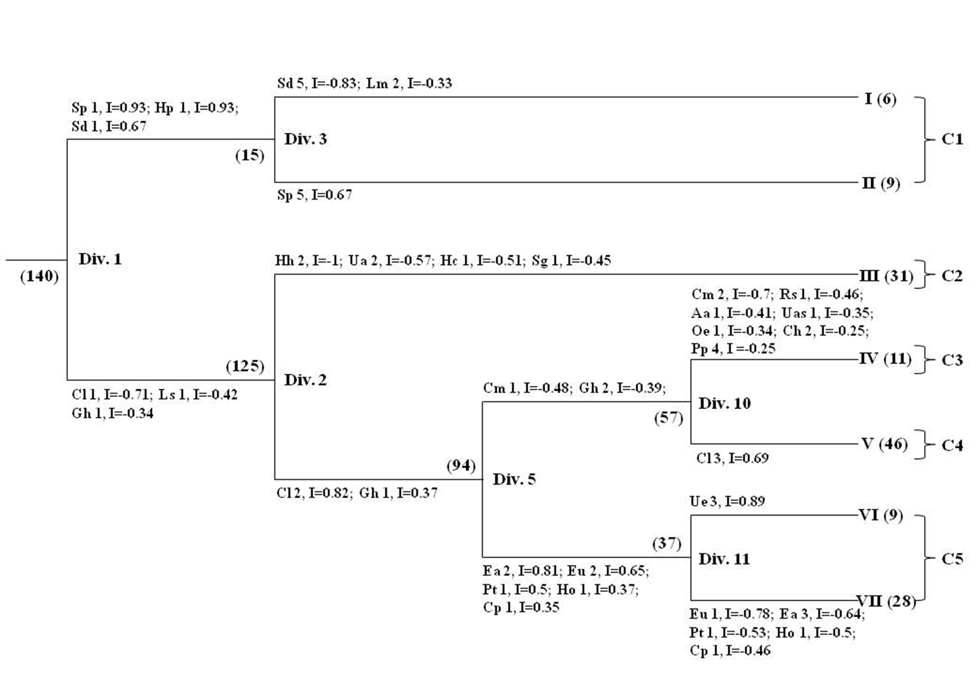

Figure 3. Dendrogram with the Twinspan classification of the relevés: the original (clusters I-VII) and that of synthesis (clusters C1-C5). The successive Twinspan divisions are identified (Div. 1, 2, 3, 5, 10 and 11), as well as the indicator species and their indicator value (I). Aa, Asparagus aphyllus; Ch, Chamaerops humilis; Cl, Cistus ladanifer; Cm, Cistus monspeliensis; Cp, Cistus populifolius; Ea, Erica australis; Eu, Erica umbellata; Gh, Genista hirsuta; Hc, Halimium calycinum; Hh, Halimium halimifolium; Ho, Halimium ocymoides; Hp, Halimione portulacoides; Ls, Lavandula stoechas; Lm, Limoniastrum monopetalum; Pt, Pterospartum tridentatum; Sd, Spartina densiflora; Sg, Stauracanthus genistoides; Sp, Sarcocornia perennis; Ua, Ulex australis; Uas, Ulex argenteus subsp. subsericeus; Ue, Ulex eriocladus. Shown for each species is the level of relative abundance on an ordinal scale (1: 0–2%; 2: 2–5%; 3: 5–10%; 4: 10–20%; 5: 20–100%). In parentheses is the number of samples of each cluster.

Fotos y pies de Fotos (las fotos originales –no enviadas-, poseen un mayor grado de calidad y resolución)
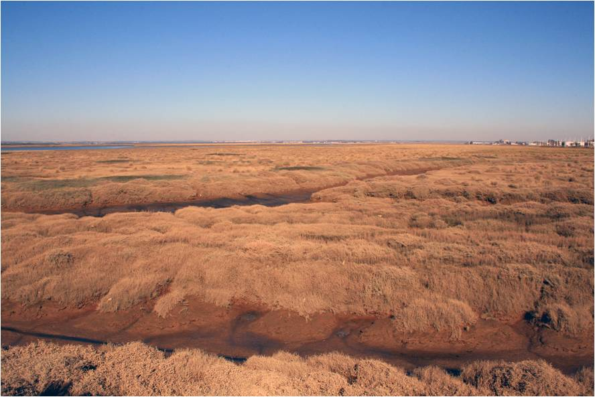

Photo 1. Halophilous coastal communities (Halimiono portulacoidis-Sarcocornietum alpinii) proper to the Marshes landscapes, in December.

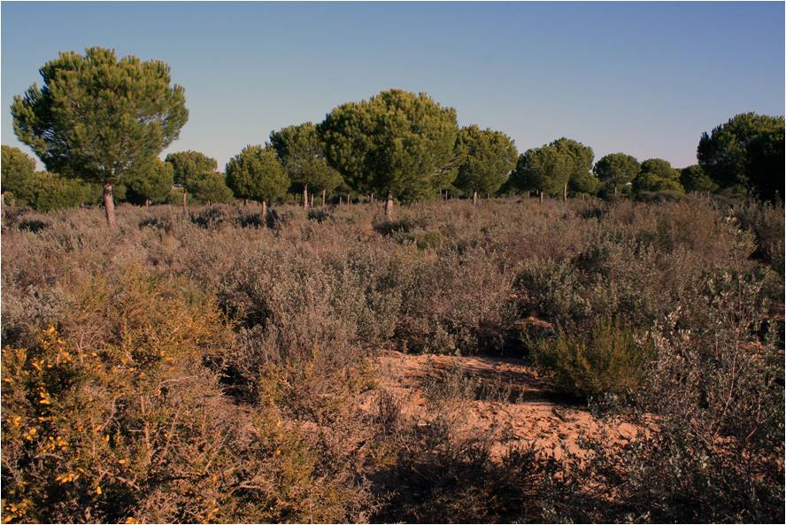

Photo 2. Xerophytic matorral or “monte blanco” characteristic of the Dunes and Sands landscapes, under canopy of Pinus pinea. In the foreground, on the left, with yellow flowers, Stauracanthus genistoides; behind it shrub layer with predominance of Halimium halimifolium.

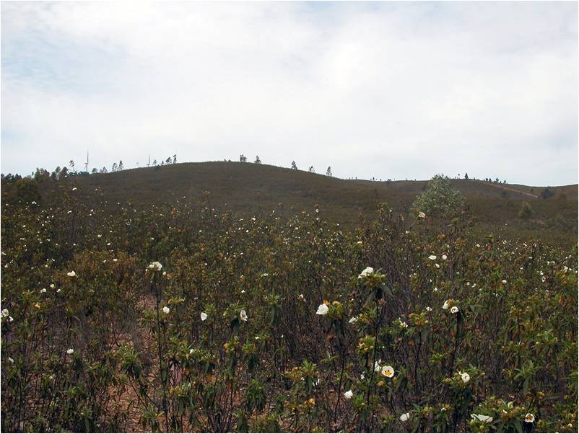

Photo 3. Rockroses with gorses of Genisto-Cistetum cistetosum ladaniferi, associated to Peneplains and Slopes landscapes. In the foreground, white flowers, Cistus ladanifer.

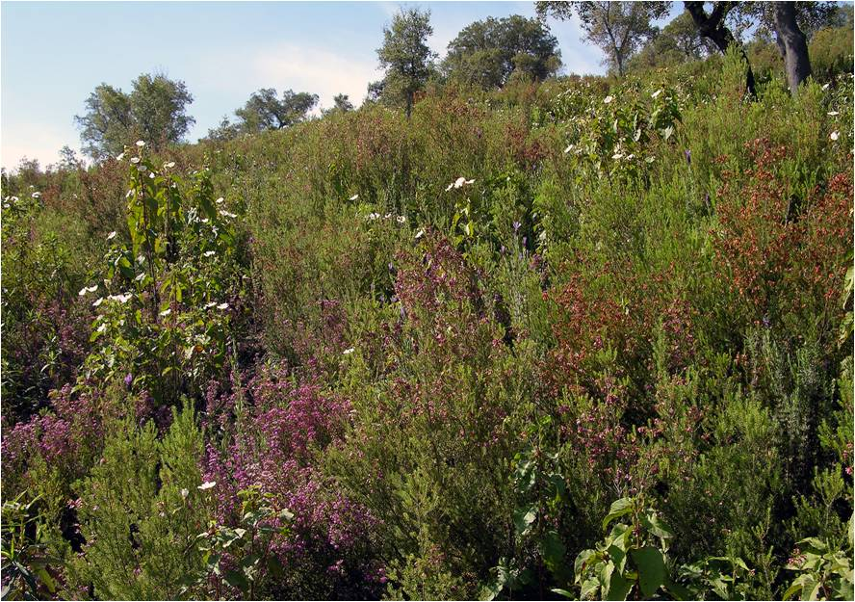

Photo 4. Rockrose-heaths of Erico australis–Cistetum populifolii, association included in C5, cluster linked to Sierras landscapes. Pink flowers: Erica australis; white flowers: Cistus populifolius.

