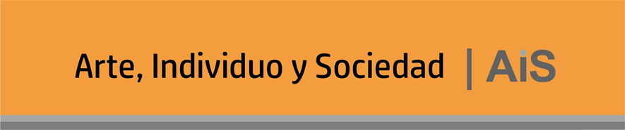

Author’s Declaration of Responsibility for Copyrighted Images and Visual Materials. Journal: Arte, Individuo y Sociedad
Statement of Responsibility Form
I, [Full name of the author(s)], holding ID/Passport number [document number], author of the article entitled:
"[Title of the article]"
HEREBY DECLARE UNDER MY RESPONSIBILITY THAT:
- All images, photographs, reproductions of artworks, graphics, or other visual materials included in the article:
  - Are my own original work, or
  - Are in the public domain, or
  - Are covered by a license that allows non-commercial academic use without modification, or
  - I have obtained the appropriate written permission from the copyright holders or their collective management organizations (e.g., VEGAP, DACS, ADAGP, etc.).
- I have included full credits and source information for each image in the manuscript and have not modified them in a way that infringes upon the moral rights of the original creator(s).
- The inclusion of such images does not violate any third-party intellectual property rights. Should any copyright infringement claims arise, I assume full legal responsibility and release the journal Arte, Individuo y Sociedad and its editorial team from any resulting liability.
- I have read and accepted the journal’s submission and publication guidelines, and I commit to complying with all its terms and conditions.

Place and date: __________________________
Signature: _____________________________
Full name: _____________________________
Email: _____________________________

